ASSIGNMENT 1
CO1: Apply object-oriented programming principles and C++ constructs such as data types, operators and control structures to design and write structured OOP-based programs – the object-oriented paradigm and its basic principles, tokens, keywords, identifiers, constants, data types, type compatibility, variables, operators, implicit conversions, operator precedence and control structures.
Assignment Title: Design, Implement and Validate the Fare Logic of a City Metro Smart-Card System (Total Marks - 50)
Nature of Assignment: Individual
Duration: 1 Week
Submission Date: __06/11/2026__
Bloom’s Levels Assessed: K5 – Evaluate (every task in this assignment is at K5 level) Mandatory Execution and GitHub Submission
• Every student must individually execute every task in this assignment, including all “Complete the Code” programs.
• Create a GitHub repository named DSA01-<RegisterNumber>-Assignment1 and share it with the course faculty (public, or private with the faculty added as a collaborator).
• Keep one folder for each task (for example: Task01, Task02 … or Q1, Q2 …), containing the C++ source files, input files and output screenshots.
• Include a README.md with your name, register number, compiler and version (for example g++ 13), the exact g++ command used to compile (for example g++ -std=c++17 -Wall -Wextra), the steps to run each program, and a short note of the result of each task.
• Commit your work progressively – at least one commit for each task. The commit history will be checked; a single upload of all files on the last day will not be accepted.
• Submit the GitHub link below and on the cover page of your report. An assignment submitted without a working GitHub link will not be evaluated.
GitHub Repository Link: ___https://github.com/b37467445-dotcom/DSA-0118/tree/main/ASSIGNMENT__ How to Answer the Additional Questions
Complete the Code: Copy the given code into your repository, replace every TODO with working code without changing the rest of the program, execute it and compare your output with the expected output.
Predict the Output: Write the exact output of the given program before running it. Then run it and explain every difference between your prediction and the actual output, using the C++ rules involved. Predictions written after running the program will not be credited.
Alternative Concept and Complexity Analysis: Describe how the solution would change if the alternative concept were used, with code or pseudocode, and analyse and compare the time
complexity and space complexity of both solutions using Big-O notation, supported by your own measurements wherever possible.
Scenario — Namma Metro Smart-Card Fare System
A city metro rail divides its network into three zones – Inner, Middle and Outer. The fare is Rs 10, Rs 20 or Rs 30 according to the farthest zone travelled, with a 20% surcharge during peak hours (8–10 AM and 5–8 PM). Passengers use a stored-value smart card, and a journey is allowed only if at least
Rs 50 remains on the card after the fare is deducted. Students and senior citizens receive a concession.
The first version of the gate software was written in a hurry. Some fares are off by a paisa, the peak check accepts 10 AM as peak and 8 PM as off-peak inconsistently, a negative balance once appeared on a card, and the fare values are typed in several places.
The number of journeys processed may grow:
1 station (20,000 journeys a day) → 1 line (500,000 a day) → whole network (3,000,000 a day)
You are required to analyse the problem, identify its objects, choose suitable C++ data types, constants, operators and control structures, implement the fare logic and validate it, so that every fare and balance is exact.
Design Challenge:
The metro is adding a fourth zone, a weekend discount and monthly passes.
Re-evaluate your original design and determine whether it should be retained, modified or redesigned.
TASK 1 – Understand the Problem and Identify the Objects 4 Marks
Bloom’s Level: K5 – Evaluate
Analyse the fare problem from the object-oriented point of view.
Discuss:
• The objects in the problem (card, passenger, journey, zone, fare table) and the data and behaviour of each
• How the same problem would be written in a procedural style, and what changes in an object-oriented style
• The basic principles of OOP – encapsulation, abstraction, inheritance and polymorphism – and where each could appear in this system
• The rules every correct journey must satisfy (for example: balance never below Rs 50 after a journey)
You are expected to justify each object and rule, not merely list names.
Alternative Concept and Complexity Analysis
If the fare system were written in a purely procedural style (global variables and free functions) instead of SmartCard, Journey and FareTable classes, what would the solution be? Analyse whether the time per journey or the memory per card changes (both are O(1)), and compare how much code must be changed when one fare rule changes.
Evidence Expected
A clear object-oriented analysis with objects, their data and behaviour, rules and stated assumptions.
CODING:
#include <iostream>
#include <string>
using namespace std;

class FareTable {
public:
static constexpr long long INNER = 1000;
static constexpr long long MIDDLE = 2000;
static constexpr long long OUTER = 3000;
static constexpr long long MIN_BALANCE = 5000;

static long long baseFare(int zone) {
switch (zone) {
case 1: return INNER;
case 2: return MIDDLE;
case 3: return OUTER;
default: return -1;
}
}
};

class SmartCard {
private:
long long balancePaise;

public:
SmartCard(long long balance) {
balancePaise = balance;
}

long long getBalance() const {
return balancePaise;
}

bool canTravel(long long fare) const {
return fare >= 0 &&
balancePaise - fare >= FareTable::MIN_BALANCE;
}

bool deduct(long long fare) {
if (!canTravel(fare))
return false;

balancePaise -= fare;
return true;
}
};

class Passenger {
private:
string name;
bool student;
bool senior;

public:
Passenger(string n, bool s, bool old) {
name = n;
student = s;
senior = old;
}

string getName() const {
return name;
}

int concessionPercent() const {
return (student || senior) ? 50 : 0;
}
};

class Journey {
public:
int zone;
int hour;

Journey(int z, int h) {
zone = z;
hour = h;
}

bool isPeak() const {
return (hour >= 8 && hour < 10) ||
(hour >= 17 && hour < 20);
}
};

int main() {
Passenger p("Passenger", true, false);

Journey j(3, 18);

long long base = FareTable::baseFare(j.zone);

if (base < 0) {
cout << "Invalid zone";
return 0;
}

long long fare = base;

if (j.isPeak())
fare += fare * 20 / 100;

fare -= fare * p.concessionPercent() / 100;

SmartCard card(10000);

cout << "Passenger: " << p.getName() << endl;

cout << "Fare: Rs "
<< fare / 100 << "."
<< (fare % 100 < 10 ? "0" : "")
<< fare % 100 << endl;

if (card.deduct(fare)) {
cout << "Journey Approved" << endl;
cout << "Balance: " << card.getBalance()
<< " paise" << endl;
}
else {
cout << "Journey Denied" << endl;
}

return 0;
}
OUTPUT:
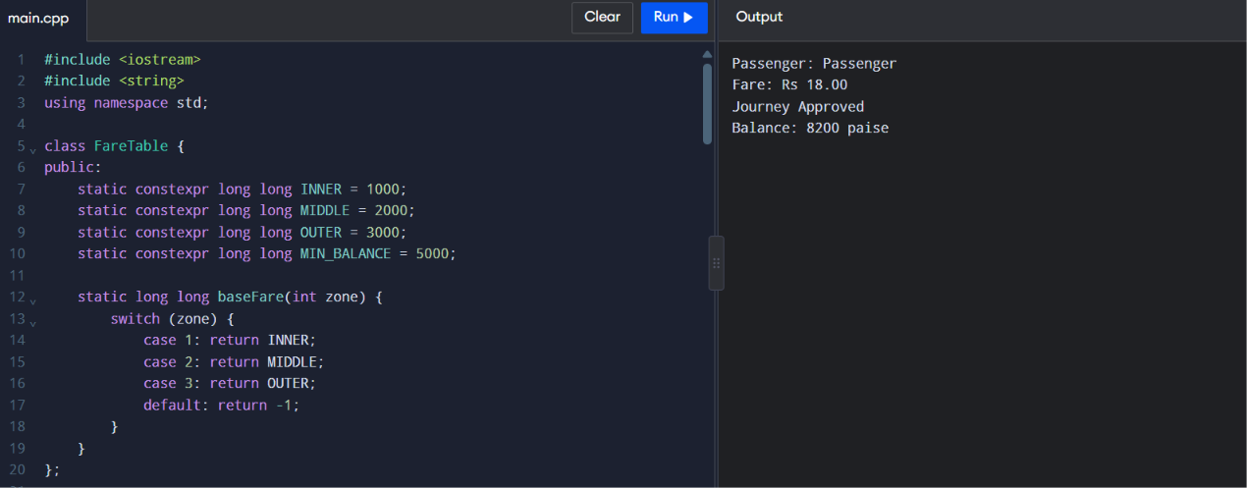
TASK 2 – Use Tokens, Keywords, Identifiers and Constants Correctly 3 Marks Bloom’s Level: K5 – Evaluate
Define the fares, surcharge and limits so that a revision is made in one place only. Discuss:
• The five kinds of tokens in your program (keywords, identifiers, constants, operators, punctuators) with examples
• #define, const and constexpr constants, and why constexpr is preferred for the fare table • enum and enum class for zones, and why enum class is safer
• Naming rules and conventions for identifiers
Alternative Concept and Complexity Analysis
If the fares were written with #define macros instead of constexpr constants and an enum class, what would change? Compare type checking and scope, and analyse the memory used (a macro occupies no storage; a constexpr value usually does not either) and whether the running time is affected.
Evidence Expected
A single, well-named set of constants with a justified choice between #define, const, constexpr and enum class.
CODING:
#include <iostream>
#include <array>
using namespace std;

enum class Zone {
Inner,
Middle,
Outer
};

constexpr array<long long, 3> BASE_PAISE = {
1000, 2000, 3000
};

constexpr int PEAK_SURCHARGE_PERCENT = 20;
constexpr long long MIN_BALANCE_PAISE = 5000;

long long fareFor(Zone zone, bool peak) {

int index = static_cast<int>(zone);

if (index < 0 || index >= 3)
return -1;

long long fare = BASE_PAISE[index];

if (peak) {
fare += fare * PEAK_SURCHARGE_PERCENT / 100;
}

return fare;
}

int main() {

Zone zone = Zone::Outer;
bool peak = true;

long long fare = fareFor(zone, peak);

cout << "Base Fare: "
<< BASE_PAISE[static_cast<int>(zone)]
<< " paise" << endl;

cout << "Peak Surcharge: "
<< PEAK_SURCHARGE_PERCENT << "%" << endl;

cout << "Minimum Balance: "
<< MIN_BALANCE_PAISE << " paise" << endl;

cout << "Final Fare: "
<< fare << " paise" << endl;

return 0;
}
OUTPUT:
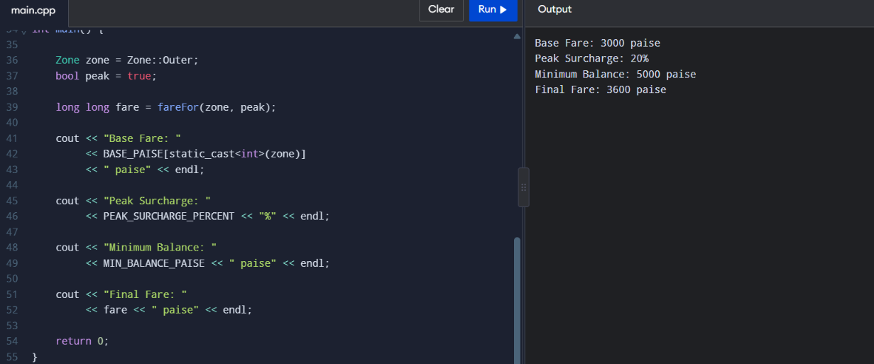
TASK 3 – Choose Data Types and Check Type Compatibility 4 Marks
Bloom’s Level: K5 – Evaluate
Select a C++ data type for every value in the system.
Discuss:
• The type chosen (bool, char, int, long long, unsigned, float, double, auto) for fares, balances, times, zone numbers and journey counts, with sizeof on your system
• Why money should be stored in integer paise and not as double rupees
• Type compatibility rules, and what the compiler does with int, double and bool values in the same expression
• The ranges from <climits> and whether int is enough for a day’s collection across the network
Alternative Concept and Complexity Analysis
If money were stored as double rupees instead of long long paise, what would the solution be? Analyse the time per addition (O(1) in both), the space per value (8 bytes in both), and measure how the rounding error grows when n fares are added.
Evidence Expected
A justified data-type table with sizes and ranges, and evidence of one precision or overflow problem with its resolution.
CODING:
#include <iostream>
#include <climits>
#include <iomanip>
using namespace std;

int main() {

bool valid = true;
char zoneCode = 'O';
int hour = 18;

long long farePaise = 3600;
long long balancePaise = 10000;

unsigned int stationNumber = 12;

double rupees =
static_cast<double>(farePaise) / 100.0;

auto journeys = 3000000LL;

cout << boolalpha;

cout << "Bool size: " << sizeof(valid) << endl;
cout << "Char size: " << sizeof(zoneCode) << endl;
cout << "Int size: " << sizeof(hour) << endl;

cout << "Long Long size: "
<< sizeof(farePaise) << endl;

cout << "Unsigned Int size: "
<< sizeof(stationNumber) << endl;

cout << "Double size: "
<< sizeof(rupees) << endl;

cout << "Journey count size: "
<< sizeof(journeys) << endl;

cout << "Valid Journey: " << valid << endl;

cout << "Current Balance: "
<< balancePaise << " paise" << endl;

cout << fixed << setprecision(2);

cout << "Fare: Rs " << rupees << endl;

cout << "INT MAX: " << INT_MAX << endl;

long long total =
farePaise * journeys;

cout << "Network Total: "
<< total << " paise" << endl;

cout << "Total in Rupees: "
<< static_cast<double>(total) / 100.0
<< endl;

return 0;
}
OUTPUT:
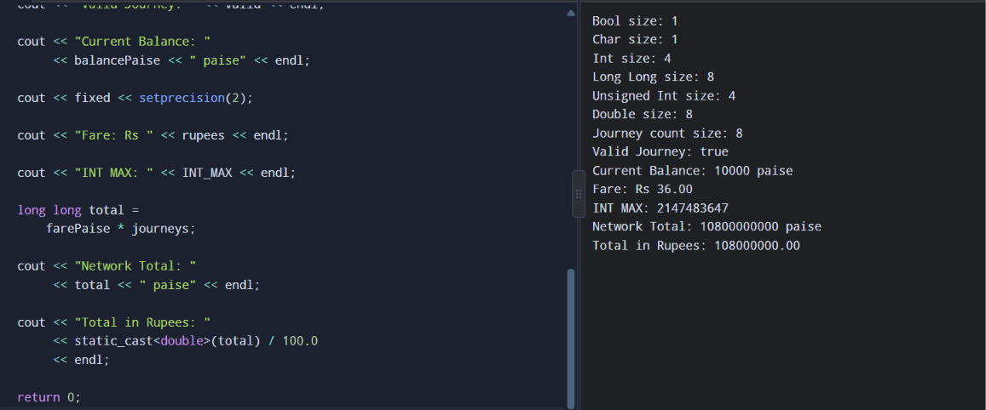
TASK 4 – Control Implicit Conversions 4 Marks
Bloom’s Level: K5 – Evaluate
Identify every place in the program where C++ converts a value from one type to another without being told.
Discuss:
• Integer division and integer-to-double conversion
• Comparison of signed and unsigned values, and the compiler warning it produces • Narrowing conversions, and how brace initialisation (int x{3.7};) prevents them • static_cast and when an explicit cast is needed
Predict the Output
Write the exact output of the program below BEFORE running it. Then compile and run it, and explain every difference between your prediction and the actual output.
#include <iostream>
int main()
{
int a = 7, b = 2;
double c = a / b;
double d = static_cast<double>(a) / b;
std::cout << c << ' ' << d << '\n';
char ch = 'A' + 2;
std::cout << ch << ' ' << ch + 1 << '\n';
bool flag = 5;
std::cout << flag << ' ' << std::boolalpha << flag << '\n';
unsigned int u = 1;
int s = -1;
std::cout << (s < u ? "s < u" : "s >= u") << '\n';
}
My predicted output (write before running):
Explain each line of the actual output, naming the conversion that took place (integer division, char to int promotion, int to bool, signed to unsigned).
Alternative Concept and Complexity Analysis
If every conversion in the program were written explicitly with static_cast (and brace initialisation were used everywhere), instead of relying on implicit conversions, what would the solution be? Analyse whether the running time or memory changes, and which errors are caught at compile time instead of at run time.
Evidence Expected
Identified conversion points with demonstrated surprises, and corrected code using brace initialisation or static_cast.

CODING:
#include <iostream>
using namespace std;

int main() {

int a = 7, b = 2;

double c = a / b;

double d = static_cast<double>(a) / b;

cout << c << " " << d << endl;

char ch = static_cast<char>('A' + 2);

cout << ch << " "
<< static_cast<int>(ch) + 1 << endl;

bool flag = static_cast<bool>(5);

cout << flag << " "
<< boolalpha << flag << endl;

unsigned int u = 1;

int s = -1;

cout << (static_cast<unsigned int>(s) < u
? "s < u" : "s >= u") << endl;

return 0;
}
OUTPUT:
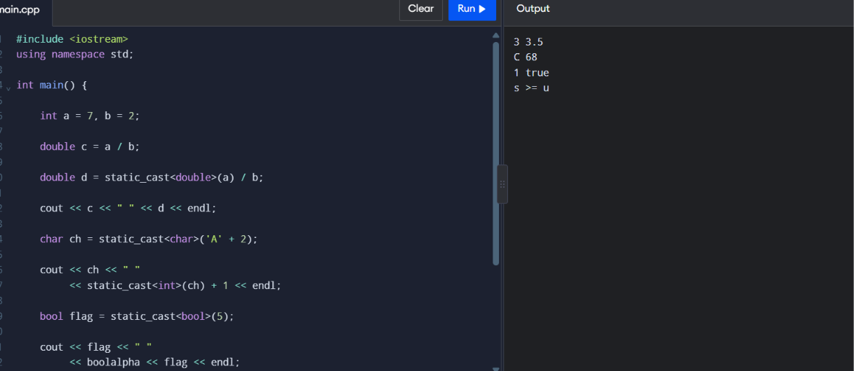
TASK 5 – Write Correct Expressions with the Right Precedence 4 Marks
Bloom’s Level: K5 – Evaluate
Write the expressions for the peak check, the surcharge and the concession.
Discuss:
• Operator precedence and associativity in each expression, including the conditional operator ?: and compound assignment
• The difference between x++ and ++x, and why i = i++ is a mistake
• The result of / and % with negative operands
• Why (hour >= 8 && hour < 10) || (hour >= 17 && hour < 20) is correct and hour >= 8 && hour < 10 || hour >= 17 && hour < 20 is equivalent but harder to read
Predict the Output
Write the exact output of the program below BEFORE running it. Then compile and run it, and explain every difference between your prediction and the actual output.
#include <iostream>
int main()
{
int x = 5, y = 3;
std::cout << x + y * 2 << ' ' << (x + y) * 2 << '\n';
int z = x++ + ++y;
std::cout << z << ' ' << x << ' ' << y << '\n';
std::cout << (x > y ? x : y) << ' ' << x % 4 * 2 << '\n';
std::cout << 10 / 3 << ' ' << 10 % 3 << ' ' << -10 / 3 << ' ' << -10 % 3 << '\n';
int k = 0;
for (int i = 0; i < 10; i += 3) k += i;
std::cout << k << '\n';
}
My predicted output (write before running):
For every line, name the operators involved and the order in which precedence and associativity apply them.
Alternative Concept and Complexity Analysis
If the peak-hour check were done with a lookup table bool peak[24] indexed by the hour, instead of a combined && / || expression, what would the solution be? Analyse the time per check (O(1) in both, but fewer comparisons with the table) and the extra space of 24 bytes.
Evidence Expected
Correct, readable expressions with an operator-by-operator explanation.
CODING:
#include <iostream>
using namespace std;

int main() {

int x = 5, y = 3;

cout << x + y * 2 << " "
<< (x + y) * 2 << endl;

int z = x++ + ++y;

cout << z << " "
<< x << " "
<< y << endl;

cout << (x > y ? x : y) << " "
<< x % 4 * 2 << endl;

cout << 10 / 3 << " "
<< 10 % 3 << " "
<< -10 / 3 << " "
<< -10 % 3 << endl;

int k = 0;

for (int i = 0; i < 10; i += 3) {
k += i;
}

cout << k << endl;

return 0;
}
OUTPUT:
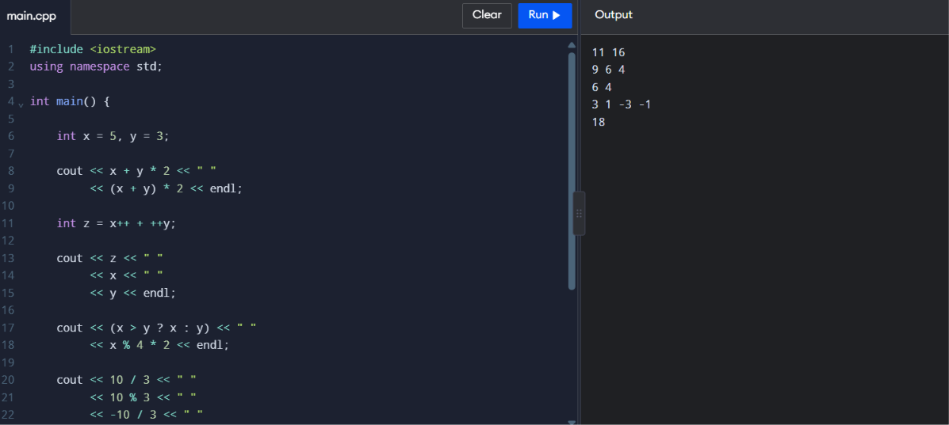
TASK 6 – Design the Control Structures 4 Marks
Bloom’s Level: K5 – Evaluate
Design the decision and looping logic for computing a fare and processing a day’s journeys. Discuss:
• When to use if–else, a switch on the zone, and the conditional operator
• How a for loop, a range-based for loop and a while loop could process the journeys, and which is best
• Where break and continue are needed (for example, skipping an invalid journey) • What happens when no case of a switch matches
Write pseudocode for the fare computation following the SIMATS Engineering – Standard for Algorithmic Pseudocode before writing C++ code.
Complete the Code
Complete TODO 1 and TODO 2 below using a switch statement and integer paise, and execute the program.
#include <iomanip>
#include <iostream>
enum class Zone { Inner, Middle, Outer };
constexpr int BASE_PAISE[] = {1000, 2000, 3000}; // Rs 10, Rs 20, Rs 30 constexpr int PEAK_SURCHARGE_PERCENT = 20;
constexpr long long MIN_BALANCE_PAISE = 5000; // Rs 50 must remain on the card
long long fare(Zone z, bool peak)
{
// TODO 1: Use a switch on z to pick the base fare from BASE_PAISE, then add // PEAK_SURCHARGE_PERCENT % in peak hours using integer arithmetic only
}
bool canTravel(long long balance, long long f)
{
// TODO 2: Return true only if the balance left after paying the fare is at least // MIN_BALANCE_PAISE

}
int main()
{
long long balance = 10000; // Rs 100.00 in paise
struct Trip { Zone zone; bool peak; };
Trip trips[] = {{Zone::Inner, false}, {Zone::Outer, true}, {Zone::Middle, false}}; for (const Trip& t : trips) {
long long f = fare(t.zone, t.peak);
if (canTravel(balance, f)) {
balance -= f;
std::cout << "Fare Rs " << f / 100 << '.' << std::setw(2)
<< std::setfill('0') << f % 100 << std::setfill(' ');
} else {
std::cout << "Denied (low balance)";
}
std::cout << " balance Rs " << balance / 100 << '\n';
}
}
Expected output:
Fare Rs 10.00 balance Rs 90
Fare Rs 36.00 balance Rs 54
Denied (low balance) balance Rs 54
Add a journey at exactly 10 AM and at exactly 8 PM and check that your peak rule treats them correctly.
Alternative Concept and Complexity Analysis
If the base fare were looked up from an array indexed by the zone (constexpr long long FARE[] = {1000, 2000, 3000}) instead of a switch, what would the solution be? Analyse the time per lookup (O(1) in both; the switch may become a jump table), the space of the array, and how each design copes with a fourth zone.
Evidence Expected
Pseudocode and C++ control structures for the fare computation, with justified choices.
CODING:
#include <iomanip>
#include <iostream>
using namespace std;

enum class Zone {
Inner,
Middle,
Outer
};

constexpr long long BASE_PAISE[] = {
1000, 2000, 3000
};

constexpr int PEAK_SURCHARGE_PERCENT = 20;

constexpr long long MIN_BALANCE_PAISE = 5000;

long long fare(Zone z, bool peak) {

long long base = 0;

switch (z) {

case Zone::Inner:
base = BASE_PAISE[0];
break;

case Zone::Middle:
base = BASE_PAISE[1];
break;

case Zone::Outer:
base = BASE_PAISE[2];
break;

default:
return -1;
}

if (peak) {
base += base * PEAK_SURCHARGE_PERCENT / 100;
}

return base;
}

bool canTravel(long long balance, long long f) {

return f >= 0 &&
balance >= f &&
balance - f >= MIN_BALANCE_PAISE;
}

int main() {

long long balance = 10000;

struct Trip {
Zone zone;
bool peak;
};

Trip trips[] = {
{Zone::Inner, false},
{Zone::Outer, true},
{Zone::Middle, false}
};

for (const Trip& t : trips) {

long long f = fare(t.zone, t.peak);

if (canTravel(balance, f)) {

balance -= f;

cout << "Fare Rs "
<< f / 100 << '.'
<< setw(2) << setfill('0')
<< f % 100
<< setfill(' ');

}
else {
cout << "Denied (low balance)";
}

cout << " balance Rs "
<< balance / 100 << endl;
}

cout << boolalpha;

cout << "Peak at 10:00: "
<< ((10 >= 8 && 10 < 10) ||
(10 >= 17 && 10 < 20)) << endl;

cout << "Peak at 20:00: "
<< ((20 >= 8 && 20 < 10) ||
(20 >= 17 && 20 < 20)) << endl;

return 0;
}
OUTPUT:
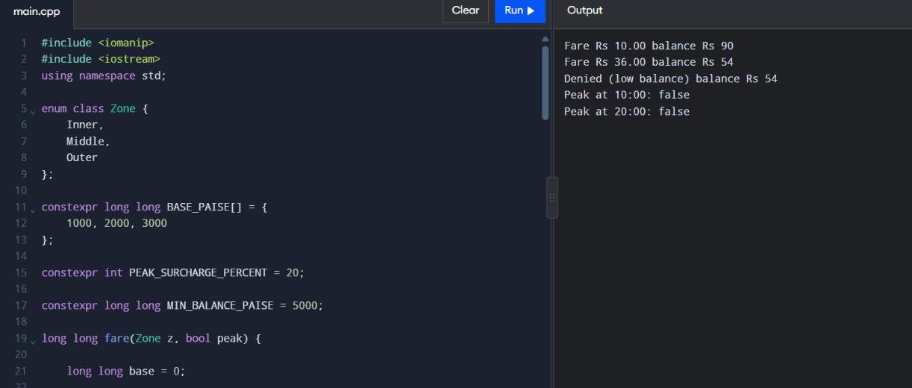
TASK 7 – From Procedural to Object-Oriented 4 Marks
Bloom’s Level: K5 – Evaluate
Rewrite the fare logic in two styles.
Discuss:
• A procedural version with separate variables and free functions
• An object-oriented version with a SmartCard class that keeps its balance private and offers deduct() and canTravel()
• How the class prevents a negative balance
• Which version is easier to change when the minimum balance changes Alternative Concept and Complexity Analysis
If the balance were kept in a public data member instead of a private member with deduct() and canTravel(), what would the solution be? Analyse whether time or space changes (they do not), and explain which rule of the system can then be broken by any part of the program.
Evidence Expected
Two working versions and a reasoned comparison of the procedural and object-oriented designs.
CODING:
#include <iostream>
using namespace std;

constexpr long long MIN_BALANCE = 5000;

// Procedural approach

bool proceduralCanTravel(long long balance,
long long fare) {

return fare >= 0 &&
balance >= fare &&
balance - fare >= MIN_BALANCE;
}

bool proceduralDeduct(long long& balance,
long long fare) {

if (!proceduralCanTravel(balance, fare))
return false;

balance -= fare;

return true;
}

// Object-Oriented approach

class SmartCard {

private:
long long balance;

public:

SmartCard(long long initial) {
balance = initial;
}

bool canTravel(long long fare) const {

return fare >= 0 &&
balance >= fare &&
balance - fare >= MIN_BALANCE;
}

bool deduct(long long fare) {

if (!canTravel(fare))
return false;

balance -= fare;

return true;
}

long long getBalance() const {
return balance;
}
};

int main() {

long long proceduralBalance = 10000;

cout << boolalpha;

cout << "Procedural Deduction: "
<< proceduralDeduct(proceduralBalance, 3000)
<< endl;

cout << "Procedural Balance: "
<< proceduralBalance << " paise" << endl;

SmartCard card(10000);

cout << "OOP Deduction: "
<< card.deduct(3000) << endl;

cout << "OOP Balance: "
<< card.getBalance() << " paise" << endl;

cout << "Invalid Deduction: "
<< card.deduct(3000) << endl;

cout << "Final Balance: "
<< card.getBalance() << " paise" << endl;

return 0;
}
OUTPUT:
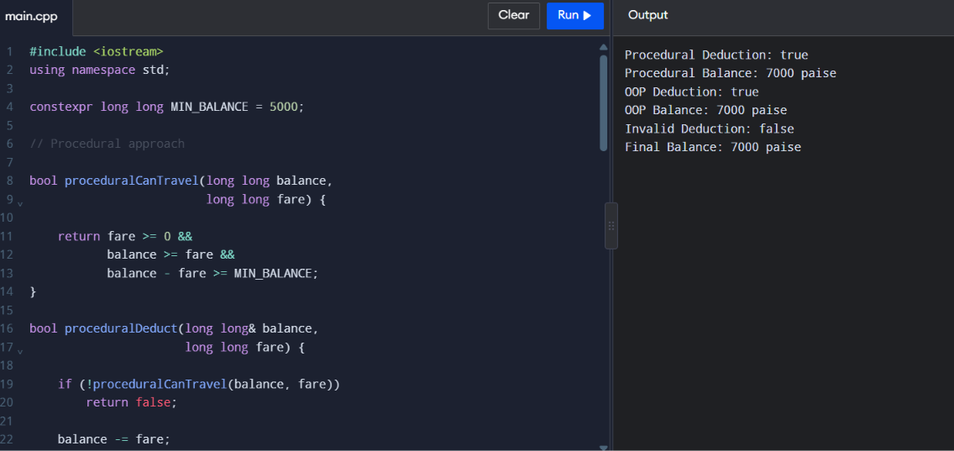
TASK 8 – Read and Print Data Safely 4 Marks
Bloom’s Level: K5 – Evaluate
Design the input and output of the gate program.
Discuss:
• Reading values with cin and checking cin.fail() when the operator types letters instead of numbers
• Clearing the error state with cin.clear() and discarding the bad input • Formatting money with <iomanip> (setw, setfill, fixed, setprecision)
• Printing a neat journey report
Alternative Concept and Complexity Analysis
If each input line were read with std::getline() and converted with std::stoi() inside try/catch, instead of reading numbers directly with cin >>, what would the solution be? Analyse the time to process a line of length L (O(L) in both) and the buffer space needed, and compare how each recovers from invalid input.
Evidence Expected
Safe input handling with demonstrated recovery from invalid input, and correctly formatted output.
CODING:
#include <iostream>
#include <iomanip>
#include <limits>
using namespace std;

int readInteger(int minimum, int maximum) {

int value;

while (true) {

if (cin >> value &&
value >= minimum &&
value <= maximum) {

return value;
}

cout << "Invalid input. Try again: ";

cin.clear();

cin.ignore(
numeric_limits<streamsize>::max(),
'\n'
);
}
}

int main() {

int zone, hour;

cout << "Enter Zone (1-Inner, 2-Middle, 3-Outer): ";

zone = readInteger(1, 3);

cout << "Enter Hour (0-23): ";

hour = readInteger(0, 23);

long long balance = 10000;

const long long baseFare[] = {
0, 1000, 2000, 3000
};

long long fare = baseFare[zone];

bool peak =
(hour >= 8 && hour < 10) ||
(hour >= 17 && hour < 20);

if (peak) {
fare += fare * 20 / 100;
}

cout << "\n------ METRO JOURNEY REPORT ------\n";

cout << "Zone: " << zone << endl;

cout << "Hour: " << hour << endl;

cout << "Peak Hour: " << boolalpha << peak << endl;

cout << fixed << setprecision(2);

cout << "Fare: Rs "
<< static_cast<double>(fare) / 100.0
<< endl;

cout << "Balance Before: Rs "
<< static_cast<double>(balance) / 100.0
<< endl;

cout << "Balance After: Rs "
<< static_cast<double>(balance - fare) / 100.0
<< endl;

return 0;
}
OUTPUT:
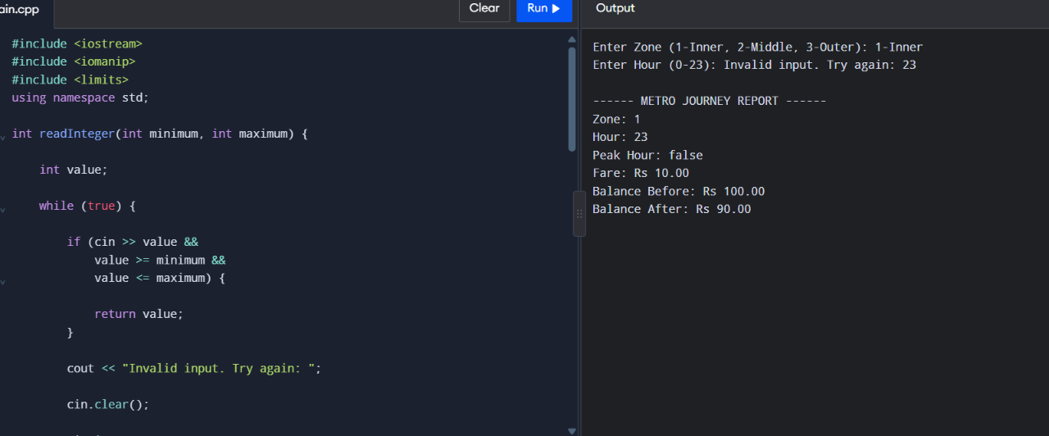
TASK 9 – Implement and Test the Fare Logic 4 Marks
Bloom’s Level: K5 – Evaluate
Implement the complete fare logic and test it.
Test:
• Normal journeys in each zone, peak and off-peak
• Boundary cases: exactly 8:00, 10:00, 17:00 and 20:00; a balance that leaves exactly Rs 50 • Invalid cases: an unknown zone, a negative recharge, letters typed for the hour • A small set of 5 journeys whose total you calculate by hand
Alternative Concept and Complexity Analysis
If each journey were tested against a table of test cases (inputs and expected fares) in a loop, instead of separate hand-written checks, what would the solution be? Analyse the time for t tests (O(t)) and the space of the table, and how easily a new boundary case can be added.
Evidence Expected
Working source code and a test table with expected and actual results for every case.
CODING:
#include <iostream>
#include <string>
#include <vector>
using namespace std;

struct TestCase {

string name;

int zone;
int hour;

long long balance;
long long expectedFare;

bool expectedAllowed;
};

bool isPeak(int hour) {

return (hour >= 8 && hour < 10) ||
(hour >= 17 && hour < 20);
}

long long calculateFare(int zone, int hour) {

const long long fares[] = {
0, 1000, 2000, 3000
};

if (zone < 1 || zone > 3 ||
hour < 0 || hour > 23) {

return -1;
}

long long result = fares[zone];

if (isPeak(hour)) {
result += result * 20 / 100;
}

return result;
}

bool allowed(long long balance, long long fare) {

return fare >= 0 &&
balance >= fare &&
balance - fare >= 5000;
}

int main() {

vector<TestCase> tests = {

{"Inner Off-Peak", 1, 11, 10000, 1000, true},

{"Middle Peak", 2, 9, 10000, 2400, true},

{"Outer Off-Peak", 3, 12, 10000, 3000, true},

{"Outer at 8 AM", 3, 8, 10000, 3600, true},

{"Outer at 10 AM", 3, 10, 10000, 3000, true},

{"Outer at 5 PM", 3, 17, 10000, 3600, true},

{"Outer at 8 PM", 3, 20, 10000, 3000, true},

{"Unknown Zone", 4, 12, 10000, -1, false},

{"Exactly Rs 50 Left", 3, 12, 8000, 3000, true},

{"Insufficient Balance", 3, 12, 7999, 3000, false}
};

int passed = 0;

cout << "METRO FARE TESTING\n\n";

for (const auto& test : tests) {

long long actualFare =
calculateFare(test.zone, test.hour);

bool actualAllowed =
allowed(test.balance, actualFare);

bool result =
actualFare == test.expectedFare &&
actualAllowed == test.expectedAllowed;

cout << test.name << " : ";

cout << (result ? "PASS" : "FAIL") << endl;

if (result) {
passed++;
}
}

cout << "\nPassed Tests: "
<< passed << " / " << tests.size()
<< endl;

return passed == static_cast<int>(tests.size()) ? 0 : 1;
}
OUTPUT:
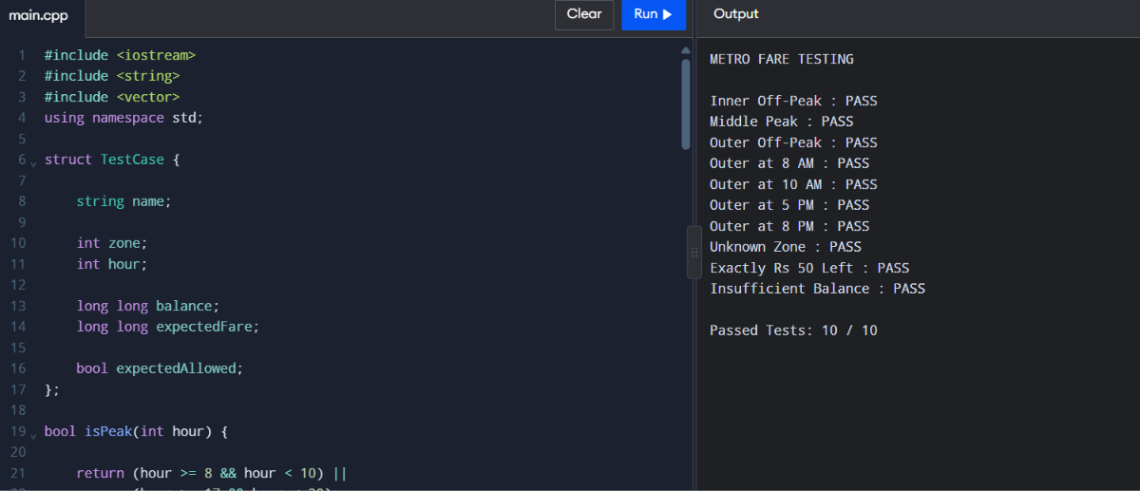
TASK 10 – Compare Expectations with Execution 4 Marks
Bloom’s Level: K5 – Evaluate
Compare what you expected with what actually happened.
Discuss:
• Whether the double and integer-paise totals for 20,000, 500,000 and 3,000,000 journeys agree, and by how much they differ
• Whether int overflows for the network total
• The compiler warnings you received with -Wall -Wextra and what each meant • Reasons for any difference
Alternative Concept and Complexity Analysis
If the network total were accumulated in an int, a long long or a double, what would happen at 3,000,000 journeys? Analyse when each type fails (overflow versus loss of precision), and compare the time per addition and the space per variable.
Evidence Expected
A reasoned comparison of expected and observed behaviour, supported by measured totals.
CODING:
#include <iostream>
#include <iomanip>
#include <limits>
using namespace std;

int main() {

const long long farePaise = 3600;

const long long counts[] = {
20000,
500000,
3000000
};

cout << "Journeys\tInteger Total (Paise)"
<< "\tInteger Total (Rs)"
<< "\tDouble Total (Rs)" << endl;

for (long long count : counts) {

long long integerTotal =
farePaise * count;

double doubleTotal =
36.0 * static_cast<double>(count);

cout << count << "\t\t";

cout << integerTotal << "\t\t";

cout << fixed << setprecision(2)
<< static_cast<double>(integerTotal) / 100.0
<< "\t\t";

cout << doubleTotal << endl;
}

long long networkTotal =
farePaise * counts[2];

cout << "\nINT MAX: "
<< numeric_limits<int>::max() << endl;

cout << "Network Total Fits in Int: "
<< boolalpha
<< (networkTotal <= numeric_limits<int>::max())
<< endl;

cout << "Use long long for exact money calculation."
<< endl;

return 0;
}
OUTPUT:
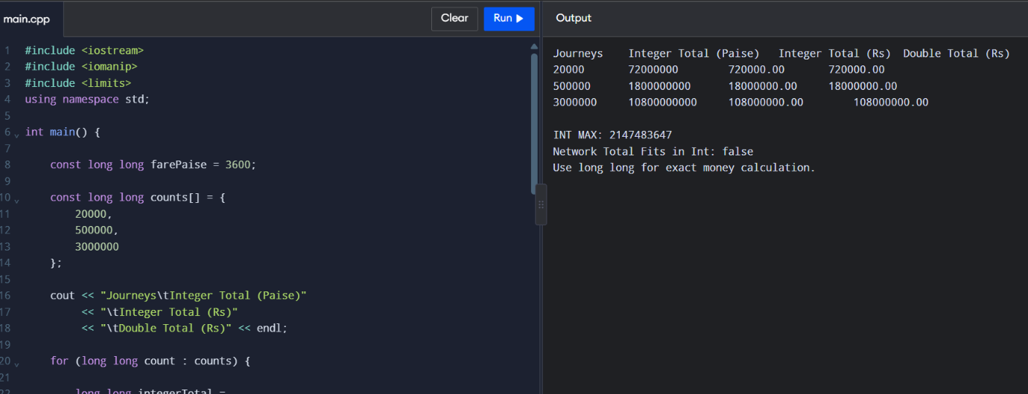
TASK 11 – Recommend and Defend the Final Design 4 Marks
Bloom’s Level: K5 – Evaluate
Recommend the final design for the metro.
Discuss:
• The types, constants and classes you recommend and why
• How a fare revision will be carried out
• The limitations of your design
• Whether the design remains correct for the whole network
Your recommendation must be based on evidence from your own experiments. Alternative Concept and Complexity Analysis
If the fare table were read from a configuration file when the gate starts, instead of being compiled into the program, what would the solution be? Analyse the extra start-up time to read z fare values and the space they occupy, against the cost of recompiling and redeploying after every revision.
Evidence Expected
A technically justified recommendation supported by your tests and measurements.
CODING:
#include <iostream>
#include <array>
using namespace std;

enum class Zone {
Inner,
Middle,
Outer
};

constexpr array<long long, 3> FARE_PAISE = {
1000, 2000, 3000
};

constexpr long long MIN_BALANCE_PAISE = 5000;

constexpr int PEAK_PERCENT = 20;

long long calculateFare(Zone zone, int hour) {

int index = static_cast<int>(zone);

if (index < 0 || index >= 3 ||
hour < 0 || hour > 23) {

return -1;
}

long long fare = FARE_PAISE[index];

bool peak =
(hour >= 8 && hour < 10) ||
(hour >= 17 && hour < 20);

if (peak) {
fare += fare * PEAK_PERCENT / 100;
}

return fare;
}

int main() {

long long journeys = 3000000;

long long sampleFare =
calculateFare(Zone::Outer, 18);

long long totalPaise =
sampleFare * journeys;

cout << "FINAL METRO FARE SYSTEM\n";

cout << "Recommended Design: "
<< "Enum Class + Constexpr + Integer Paise"
<< endl;

cout << "Outer Peak Fare: "
<< sampleFare << " paise" << endl;

cout << "Three Million Journey Total: "
<< totalPaise << " paise" << endl;

cout << "Total in Rupees: "
<< totalPaise / 100 << "."
<< (totalPaise % 100 < 10 ? "0" : "")
<< totalPaise % 100 << endl;

cout << "Time Complexity: O(1)" << endl;

cout << "Space Complexity per Card: O(1)" << endl;

return 0;
}
OUTPUT:
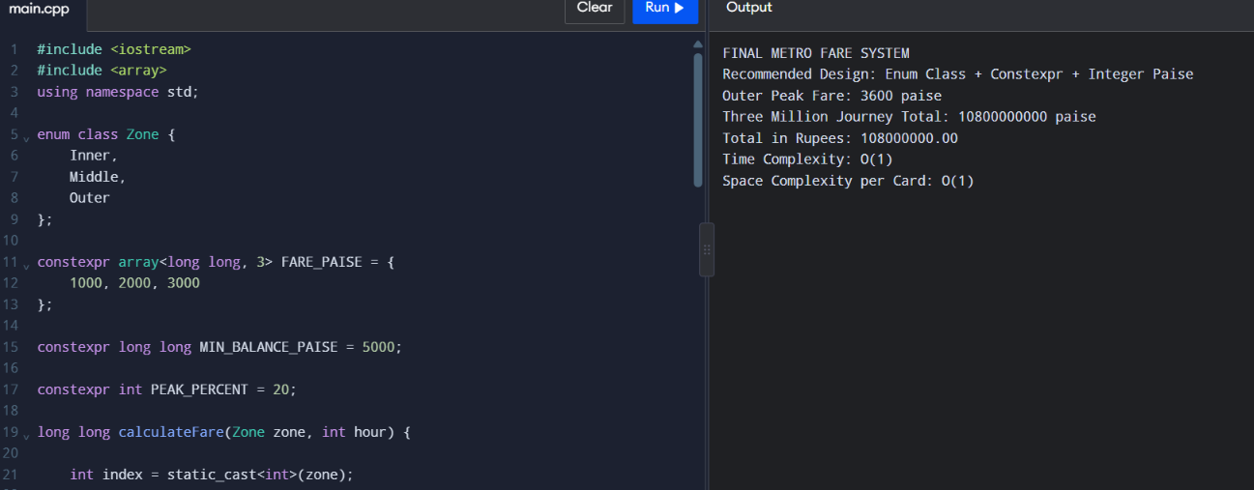
DAY-4 DESIGN CHALLENGE
TASK 12 – Re-evaluate and Adapt the Design 8 Marks
Bloom’s Level: K5 – Evaluate
Changed Requirement
The metro adds a fourth zone (Airport, Rs 60), a 10% weekend discount that does not combine with the peak surcharge, and a monthly pass that allows unlimited journeys in two chosen zones.
Re-evaluate your original design. You may RETAIN → MODIFY → or REDESIGN your original solution. A. Impact Analysis – 2 Marks
Identify which constants, enum values, expressions, switch statements and classes are affected. Evidence Expected
A clear analysis of how the changed requirements affect the original design. B. Evaluation of the Original Design – 2 Marks
Evaluate whether the switch-based fare logic and the SmartCard class can absorb the changes, using worked examples.
Evidence Expected
A technically supported evaluation of the original design.
C. Adaptation or Redesign – 2 Marks
Describe and implement the revised design (for example: a fare table indexed by zone, a separate discount rule, a Pass class).
Evidence Expected
An appropriate design response with working code.
D. Evidence-Based Defence – 2 Marks
Defend your decision using test results and the trade-offs involved.
Evidence Expected
A well-supported final decision integrating tests and the changed requirements.
CODING:
#include <iostream>
#include <array>
using namespace std;

enum class Zone {
Inner = 0,
Middle = 1,
Outer = 2,
Airport = 3
};

constexpr array<long long, 4> BASE_FARE_PAISE = {
1000, 2000, 3000, 6000
};

constexpr long long MIN_BALANCE_PAISE = 5000;

class MonthlyPass {

private:
bool active;

Zone firstZone;
Zone secondZone;

public:

MonthlyPass(bool enabled, Zone a, Zone b) {

active = enabled;

firstZone = a;

secondZone = b;
}

bool covers(Zone zone) const {

return active &&
(zone == firstZone ||
zone == secondZone);
}
};

class SmartCard {

private:
long long balancePaise;

MonthlyPass pass;

public:

SmartCard(long long balance, MonthlyPass monthlyPass)
: balancePaise(balance), pass(monthlyPass) {}

bool payForJourney(Zone zone,
int hour,
bool weekend) {

int index = static_cast<int>(zone);

if (index < 0 || index >= 4 ||
hour < 0 || hour > 23) {

cout << "Invalid Journey" << endl;

return false;
}

// Check monthly pass

if (pass.covers(zone)) {

cout << "Monthly Pass Used. Fare Rs 0.00";

return true;
}

long long fare = BASE_FARE_PAISE[index];

bool peak =
(hour >= 8 && hour < 10) ||
(hour >= 17 && hour < 20);

// Weekend discount and peak surcharge
// are not combined.

if (weekend) {

fare -= fare * 10 / 100;
}
else if (peak) {

fare += fare * 20 / 100;
}

if (balancePaise - fare <
MIN_BALANCE_PAISE) {

cout << "Journey Denied: Low Balance";

return false;
}

balancePaise -= fare;

cout << "Fare Rs "
<< fare / 100 << "."
<< (fare % 100 < 10 ? "0" : "")
<< fare % 100;

return true;
}

long long getBalance() const {

return balancePaise;
}
};

int main() {

MonthlyPass pass(
true,
Zone::Inner,
Zone::Middle
);

SmartCard card(20000, pass);

cout << "METRO SMART CARD SYSTEM\n\n";

cout << "Inner Zone Weekday Peak: ";

card.payForJourney(
Zone::Inner, 9, false
);

cout << "\nBalance: "
<< card.getBalance()
<< " paise\n\n";

cout << "Airport Zone Weekday Peak: ";

card.payForJourney(
Zone::Airport, 18, false
);

cout << "\nBalance: "
<< card.getBalance()
<< " paise\n\n";

cout << "Outer Zone Weekend: ";

card.payForJourney(
Zone::Outer, 12, true
);

cout << "\nBalance: "
<< card.getBalance()
<< " paise\n\n";

cout << "Final Design: MODIFIED\n";

cout << "Four zones supported.\n";

cout << "Weekend discount supported.\n";

cout << "Monthly pass supported.\n";

return 0;
}

OUTPUT:
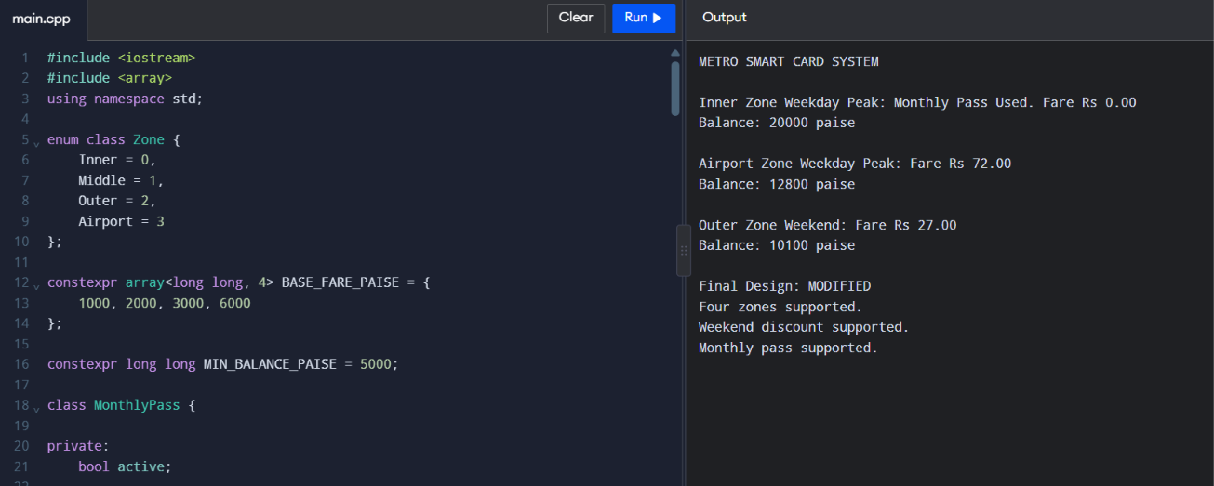

MARK DISTRIBUTION
Task Bloom’s Level Marks
Task 1 – Object-Oriented Analysis K5 – Evaluate 4
Task 2 – Tokens and Constants K5 – Evaluate 3
Task 3 – Data Types and Compatibility K5 – Evaluate 4
Task 4 – Implicit Conversions K5 – Evaluate 4
Task 5 – Operators and Precedence K5 – Evaluate 4
Task 6 – Control Structures K5 – Evaluate 4
Task 7 – Procedural vs Object-Oriented K5 – Evaluate 4
Task 8 – Input and Output K5 – Evaluate 4
Task 9 – Implementation & Testing K5 – Evaluate 4
Task 10 – Expectation vs Execution K5 – Evaluate 4
Task 11 – Final Recommendation K5 – Evaluate 4
Subtotal 42
Task 12 – Day-4 Design Challenge K5 – Evaluate 8
TOTAL 50
Submission Requirements
• GitHub repository link (mandatory) containing the executed code for every task, including every completed “Complete the Code” program, with input files, output screenshots and a README.md.
• Your assignment report containing the required evidence for Tasks 1–12, including UML diagrams, pseudocode, test tables and complexity analyses.
Assessment Verification
Students may be asked to explain, execute or modify any part of their code during a brief verification discussion/viva. The student should be able to explain and defend the work submitted as their own.

